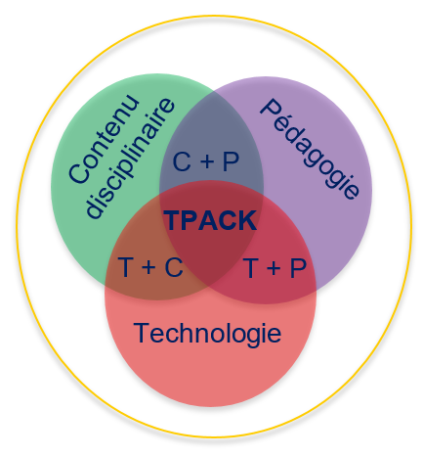
Planning a pedagogical activity
consistent with the technology
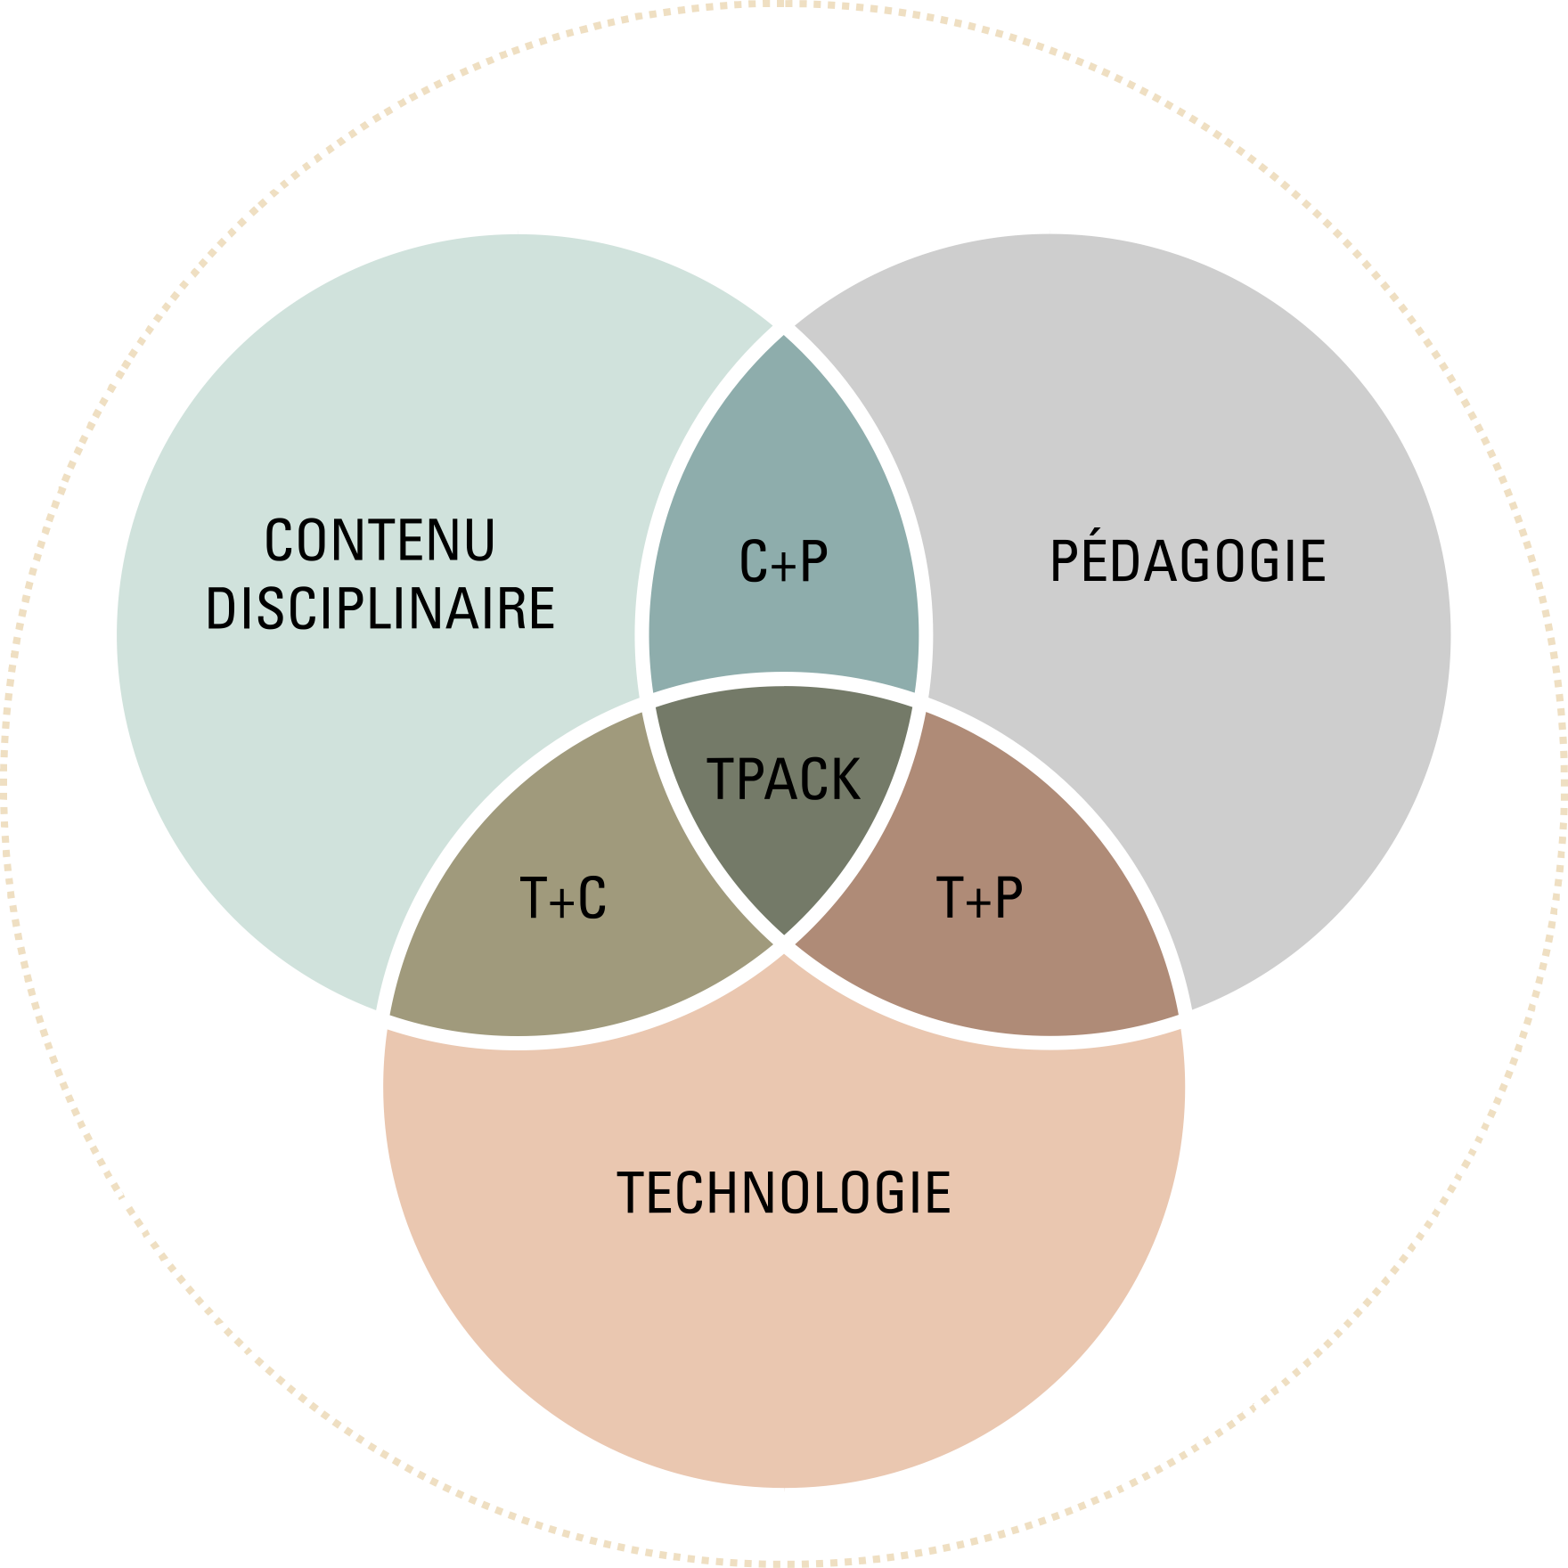
Content (C)
Activity title
Activity context
Activity duration
Activity objective(s)
Moment (M) | To be done by the teacher (P) | Technological tools (T) | To be done by  the student (P) | Technological tools (T) | Assessment  and appraisal (TPACK)
Before (preparation)
During (execution)
After (feedback and follow-up)

