Planning a pedagogical activity consistent with the technology

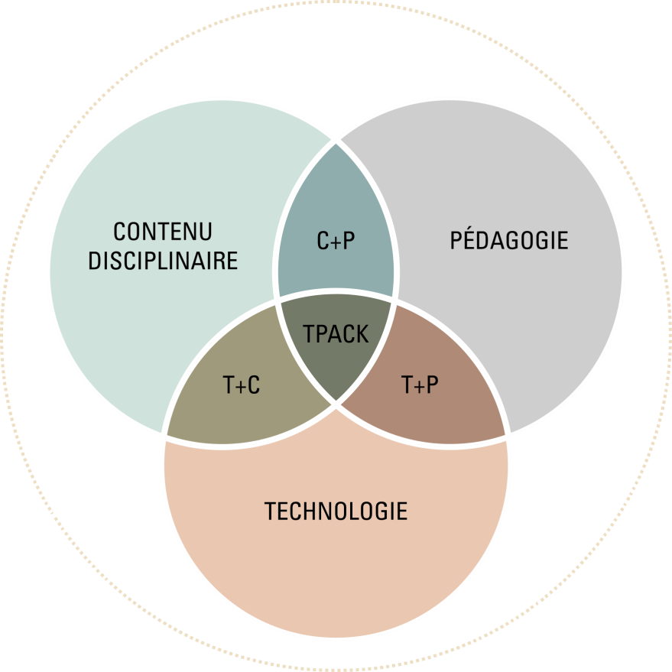

Content (C): Math, Secondary III - algebraic resolution
Selected pedagogical activity | Puzzle to solve (present a problem requiring algebraic resolution) https://www.polymtl.ca/vignettes/enigme-resoudre
Activity objective | Ability to solve a two-variable first-degree system of equations of the form y = ax + b algebraically (by comparison).
Sequence | Explanation in synchronous Exercise in asynchronous
Activity duration | Explanations: 20 minutes  Availability of the teacher throughout the week to answer questions.
Moment (M) | To be done by the teacher (P) | Technological tools (T) | To be done by the student (P) | Technological tools (T) | Assessment and appraisal (TPACK)
Before the course (preparation) | Go back to the equation on the right (prior knowledge). | Moodle | Read the problem to be solved. | Moodle
 | Share the problem to be solved with the students before the synchronous session. | Moodle | Attempt to solve the problem by reactivating prior knowledge. | Moodle
 | Answer students' questions about when and how to meet. | By Teams (via chat or publication wall) | Question the teacher if necessary. | By Teams (via chat or publication wall)
 | Prepare a clip explaining the new concept in order to make it available after the session. | Screencastify

Moment (M) | To be done by the teacher (P) | Technological tools (T) | To be done by the student (P) | Technological tools (T) | Assessment and appraisal (TPACK)
During the course (execution) | Reread the shared problem with the students before class. | Teams | Share strategies and questions. | Teams
 | Have students discuss the adopted strategies. | Share the screen with students so that they can all see the problem.
 | Explain how a two-variable system of first-degree equations of the form y = ax + b is solved. |  | Question as needed. | Teams
After the course (feedback, follow-up and adjustment) | Provide a video explaining the algebraic resolution. | Moodle | Do the exercises. | Moodle
 | Provide exercises for the students to do.
 | Answer questions and provide the students with feedback.
 | Validate the strategies of the students.

